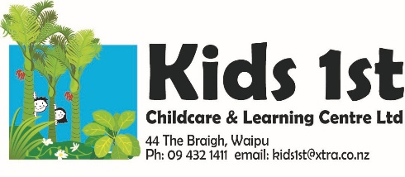

Newsletter January 2021
Nau mai haere mai, welcome whanau. A big welcome to everyone, so lovely to see most of the tamariki back now after the holidays. Best wishes to all our whanau for a safe, happy and healthy 2021. We are so looking forward to lots of fun and learning in the year ahead.
Haere mai, a big welcome to Judy Edgar, our wonderful, multi-talented teacher. Most of you will have met Judy by now, please introduce yourselves. Judy will be working with the tamariki Monday to Friday. We look forward to lots of fun and learning with Judy.
Haere mai and welcome to all the new tamariki and their whanau: Welcome Avalyn Bell, Harvey Wright, Hugo Perry, Hunter Mackay, Henry McDonald, Maggie and Isabella Jones, Eunso Park and Willow Broodkoorn-Ridge. We are delighted to welcome you to Kids 1st and look forward to getting to know you all. We have a wonderful team of kaiako (teachers) with many years of experience to support you and your child, please feel free to chat with us in regards to your child’s learning and development. We have access to professional help through the Ministry of Education Learning Support.
Haere ra to Fred Rawson and Ka’Tleya Waetford who are off to school and Jack Rawson and Aiden Holland who have moved to a centre in Ruakaka.
Haere ra to Jenna Pille, our wonderful teacher who has moved to a new position at a centre in Ruakaka. We will all miss Jenna very much. We had a farewell afternoon tea in January to farewell our friend and colleague.
We will be having a Whakatau (Informal powhiri) to welcome our new whanau, on Thursday 18th February at 5.30p.m. All families are welcome, come for a barbecue dinner, we will supply the food, please bring cutlery and plates. This is a great opportunity to meet all the new families, we look forward to seeing you there. Please RSVP on the sheet left at reception.
Just a few reminders:
Please sunblock your child before you come in and stamp their hand so we know. There’s spare sunblock at the reception desk if you need it. We then sunblock the children after lunch and stamp their other hand.
Please scan the QR code and sign in.
Monthly registers are left on the reception desk, these are a Ministry requirement, please check you have signed. Thanks.
Dates to remember:
Whakatau (Informal Powhiri)
Thursday 18 February 5.30p.m. BBQ dinner, just bring your whanau, plates and cutlery. Everyone welcome.
Nature programme: for the eldest 9 children. Please let us know when you can be a parent helper. Dates: February 19th, March 5th, 19th, April 9th. We need your help parents or we cannot go. Please see one of the teachers to put your name down.
Maori Language: To promote Maori language in our community we include some Te Reo Maori in our monthly newsletters for you to have a go with your children. Try this counting song in Te Reo with your child: tahi is one, rua is two, toru is number three, wha is four, rima is five, 1,2,3,4,5.
Healthy Eating and Active Movement = healthy children
Please take a look at the information sent regarding choking. We encourage you to check this information emailed out to everyone to ensure you minimise the risks of choking. Please do not send along drinks and drink bottles, we don’t want to risk other children drinking from your child’s water bottle. Cups and water are available throughout the entire day.

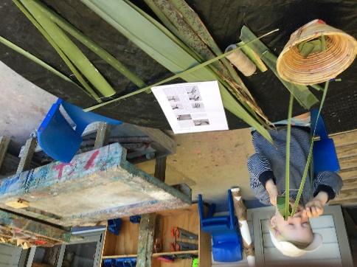
Our Programme: Learning through play to be: “Competent and confident learners and communicators, healthy in mind body and spirit, secure in their sense of belonging and in the knowledge that they make a valued contribution to society.” Te Whāriki 2017
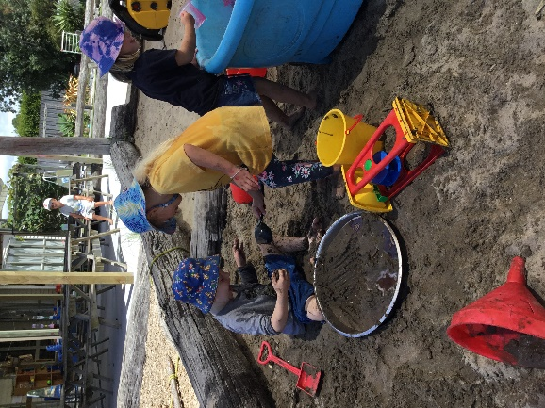
Underpinning our practice:
Our whānau aspirations
Te Tiriti o Waitangi
Te Whāriki (NZ Early Childhood Curriculum):
- Mana Atua – Wellbeing
- Mana Whenua – Belonging
- Mana Tangata – Contribution
- Mana Reo – Communication
- Mana Aotūroa - Exploration
- Whakamana – Empowerment
- Kotahitanga – Holistic development
- Whānau Tangata – Family and Community
- Ngā Hononga - Relationships
Mātauranga Māori - Māori ways of being and engaging in the world
Kaitiakitanga – Guardianship and protection of our taonga (treasures)
Our Philosophy
RIE Philosophy
Code of Ethics
Professional Teaching Standards
Professional Growth Cycle

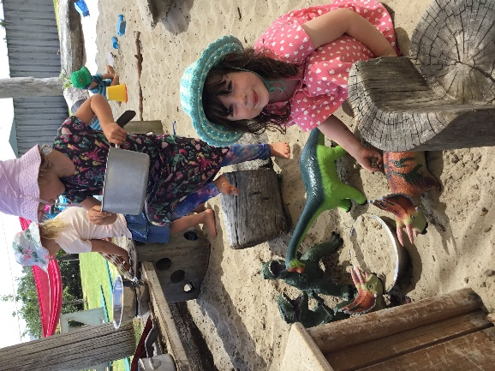

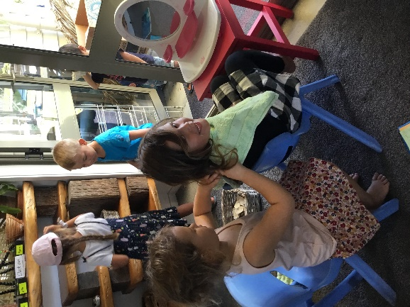
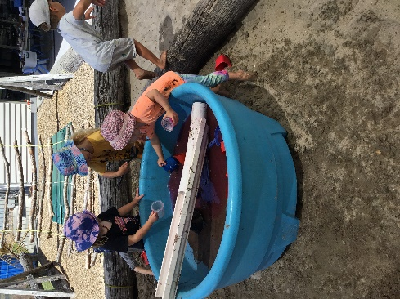
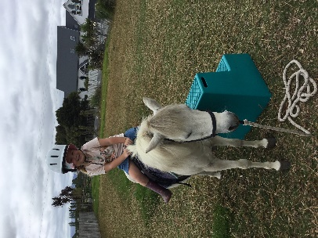
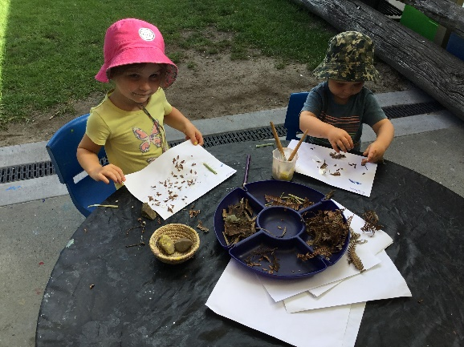
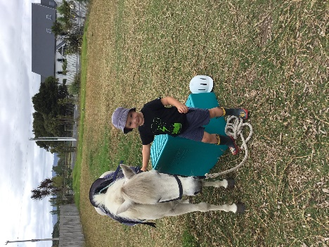
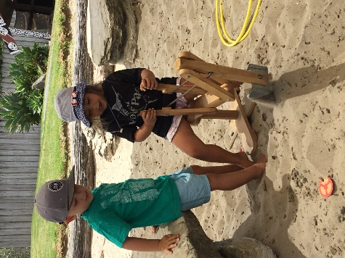
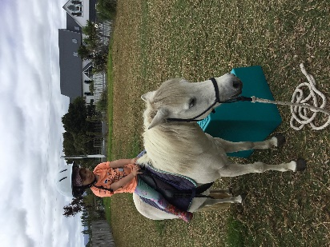
Happy February! Ka kite ano, Noela, Dawn, Delaine, Robyn, Kathy, Amber, Sarah and Judy.

