-.0

Newsletter
December 2022/January 2023
Tena kotou katoa whanau. Happy new year! Nau mai haere mai, welcome to our new tamariki and their families who have recently joined Kids 1st; Lyric Nathan-Tuake, Ruby Mathers, Violet Blythe, Stevie Patia-Tepania and Bodhi Pyle. We look forward to getting to know you and your child and we welcome you to our Kids 1st whanau. We will be having an informal powhiri on Thursday 16 February at 9.15a.m. to welcome our new whanau. Everyone is welcome to come along and stay for kai. Please let us know numbers by Tuesday 14 February. We have farewelled many friends who have headed to school: Tristan Garner, Pearl Bowie, Sadie Andrews, Barnaby Marcinowicz, Melakye Carter and Kaea Patia-Tepania. We wish you all the very best; happy school days.
Our expansion is well underway, estimated completion is April 2023. Plans are on the wall in reception. Please let us know if you wish to book a younger sibling in as soon as possible.
Sunscreen and Sun hats: Please remember hats, protective clothing and sunblock every day, rain or shine as the weather is very unpredictable.
Dates to remember:
Chinese New Year:
Here at Kids 7th-10th February we will be celebrating Chinese New Year, the year of the rabbit this week. Come along dressed up if you can!
Powhiri: Thursday 16th February 9.15a.m.
Nature programme: for the eldest 9 children. Please let us know when you can be a parent helper. Dates: February 17th, March 3rd, 17th and 31st. Please see one of the teachers to put your name down as a helper.
Monthly coffee mornings: Tuesday 21st February 10a.m. Come along and meet other whanau, see your child at play and have morning tea.
Maori Language: To promote Māori language in our community we include some Te Reo Māori in our monthly newsletters for you to have a go with your children. How is it going? Try this:
Ata mārie (good morning.)
Signing in and out… please remember to sign; this is a MOE document so we need your signature for both signing in and out. Thanks.
Sunscreen and Sun hats: Please remember hats, protective clothing, (please avoid strappy dresses and tops) shoulders covered are much more sun safe. Please sunblock every day, rain or shine as the weather is very unpredictable.
Kaiako:
We have an amazing team, with all our staff qualified teachers along with many years of experience. If you have any concerns about your child please chat to us, we have a wealth of knowledge and have access to professionals from the Ministry of Education. Health, behaviour and development – we can refer you to professionals from the ministry.
Kaiako Professional Development:
Kathy and Judy just renewed their First Aid Courses. All our kaiako have current certificates.
Children’s interests:
The children are very interested in birds, eggs and nests. Nests are being made with collage resources and much creative imagination. Judy has been working with the children to make bird feeders with seeds. There is also a lot of interest in construction and machinery inspired perhaps by our expansion. Please comment on your children’s learning stories, which we post on Storypark for you to read, as this gives us further insight into your child’s interests and home life. Together in partnership we can do so much for your child.

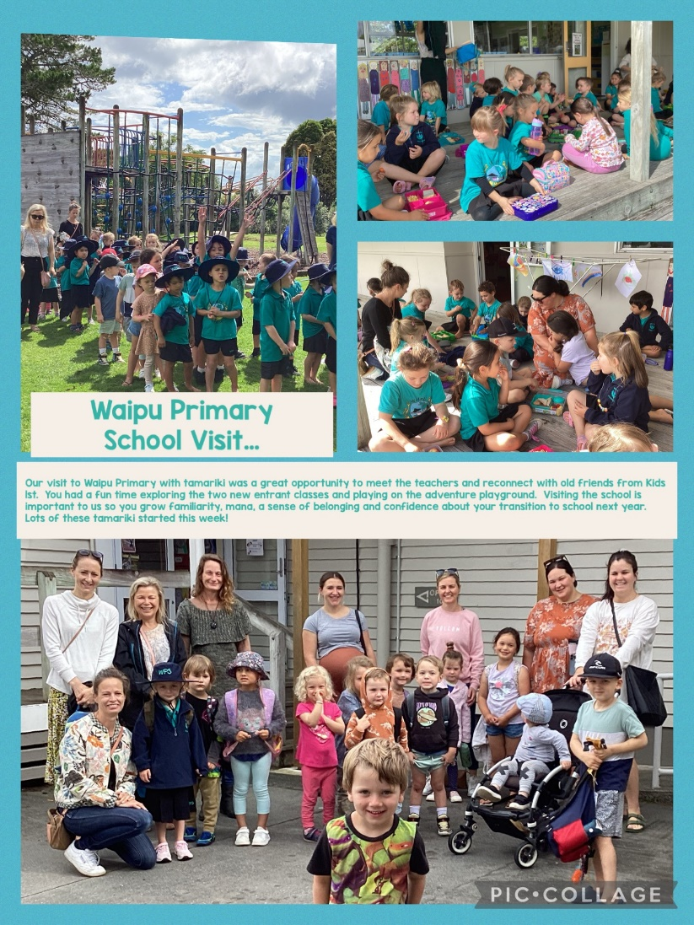
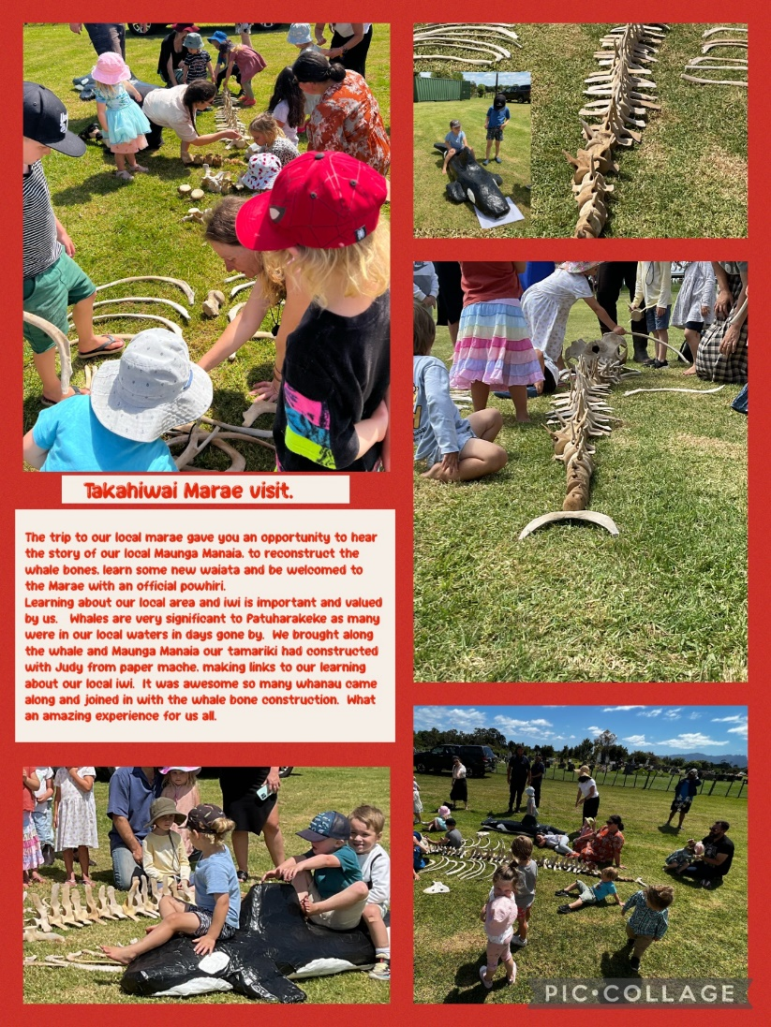
Have a wonderful weekend. Ngā mihi, Noela, Sarah, Amber, Delaine, Kathy, Judy, Sonya and Debra.
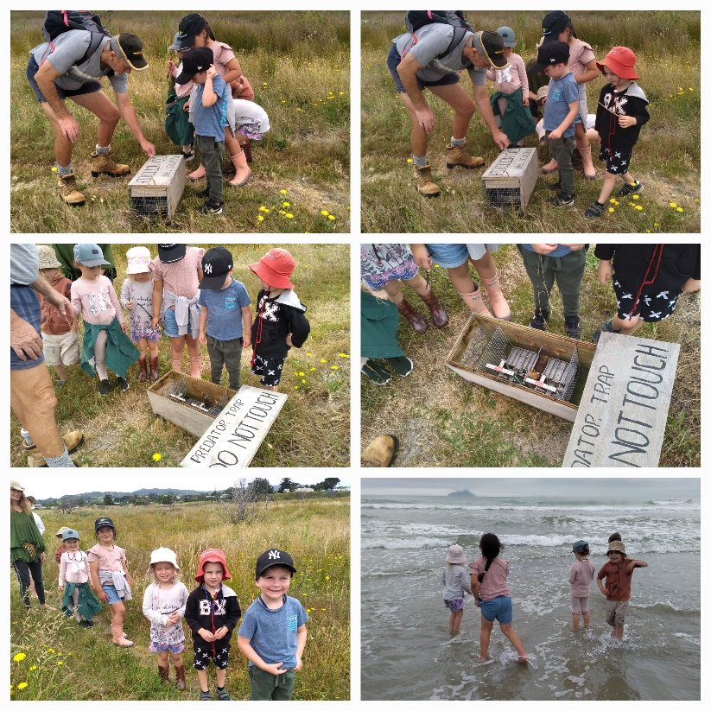
Our nature programme … visiting Ruakaka Wildlife Reserve. We learnt about protecting our taonga, the birds that live in this area, our plants, river and sea. We saw our local maunga Manaia and talked about being kaitiaki, protectors of our treasures. Young conservationists!
Our Christmas Party… treasure hunt, beach races, picnic dinner and of course Santa Claus!!!
