Newsletter
March 2023
Kia ora whanau. Haere mai and welcome to all the new tamariki and their whanau: Charlie Charvat, Clare Ruddell, Dayla Prakash, Ellie Hardie, Kaysyn and Reidyn Turanga and Paddy Wright. We are really enjoying getting to know your child and look forward to getting to know their whanau too. Thank you to those who made it to our whakatau (informal powhiri) to welcome our new whanau. We will have another one next term.
Haere ra to Charlie-Rose and her whanau who have moved south. Also haere ra to the following tamariki who have or are about to head off on their next adventure … school!! Emma Currie, Mack Hillier, Riqo Waata and Thomas Hosznyak. A smooth transition to school is important, working in with the schools is important to us. Neuroscience research reveals that when a child is happy their brain is available for learning, so this is what we aim for… “Competent and confident learners and communicators, healthy in mind, body and spirit, secure in their sense of belonging and in the knowledge that they make a valued contribution to society” NZ Early Childhood Curriculum Te Whāriki 2017. Waipu Primary New Entrant classes are visiting us on Wednesday 5th April from 9a.m. to 11a.m. We invite you to come along and meet the teachers and enjoy morning tea.
Dates to remember: Nature programme: for the eldest 9 children. Please let us know when you can be a parent helper. Dates: 31st March, 28th April, 12th and 26th May. We need your help parents or we cannot go. Please see one of the teachers to put your name down.
Waipu Primary New Entrant Class Visit us: Wednesday 5th April 9-11a.m.
Kapa Haka: Alex Murrie from our Bream Bay Kahui Ako is visiting throughout this term and next in preparation for Matariki.
Easter: We are closed on Good Friday 7th April and Easter Monday 10th April.
Maori Language: To promote Maori language in our community we include some Te Reo Maori in our monthly newsletters for you to have a go with your children. Try using these phrase when reading a pukapuka (book) with your child: Huri te whārangi (turn the page)
Healthy Eating and Active Movement = healthy children We encourage healthy eating and being active. Please no lollies in lunch boxes. Check out this website for healthy meal ideas: https://www.heartfoundation.org.nz/wellbeing/healthy-
Expansion: Our expansion is well under way, we are so excited to be able to offer more spaces, the painting is next and the playground. Apologies for the ongoing car parking congestion. Please park so there is room for others. Thanks.
Screen time: Please consider carefully the amount of time your child has on screens and what they are watching. Games or videos with aggressive play are not recommended. As per Dame Whina Cooper’s quote:
“Take care of our children. Take care of what they hear, take care of what they see, take care of what they feel. For how the children grow, so will be the shape of Aotearoa.”
Our Programme: Our tamariki are thoroughly enjoying the new basketball hoop, stepping stones, outdoor bean bags and numbered cones. Engaging children in active movement is highly valued.
Learning through play, this is the work of our tamariki. “In Te Whāriki children are positioned as confident and competent learners from birth. They learn by engaging in meaningful interactions with people, places and things – a process that continues throughout their lifetimes.” NZ Early Childhood Curriculum Te Whāriki 2017.
We work to encompass our very multi-cultural centre to incorporate the languages and symbols of children’s own and other cultures so they are promoted and protected, enhancing the child’s mana. We have celebrated Chinese New Year and recently the Irish Culture with St Patricks Day. If you have any resources, such as costumes, songs, books, photos etc about your families culture please let us know.

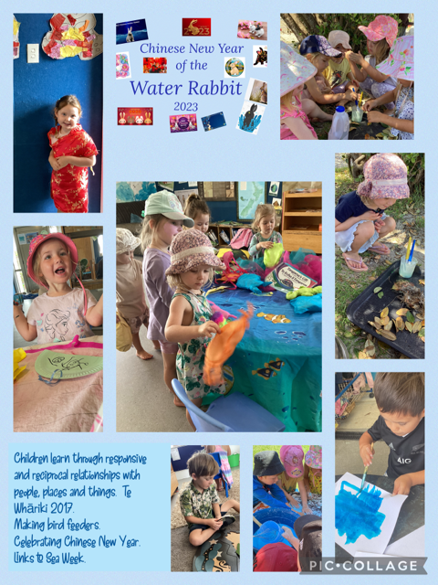
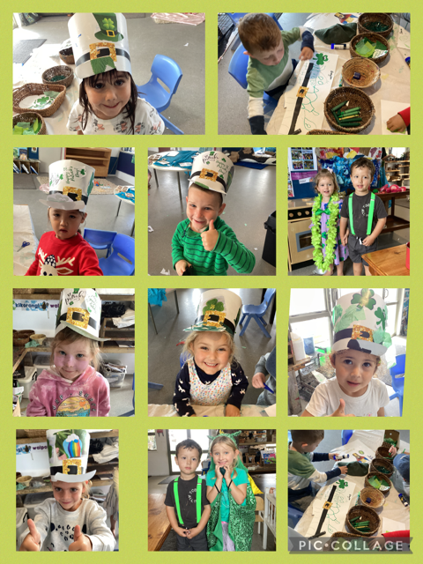
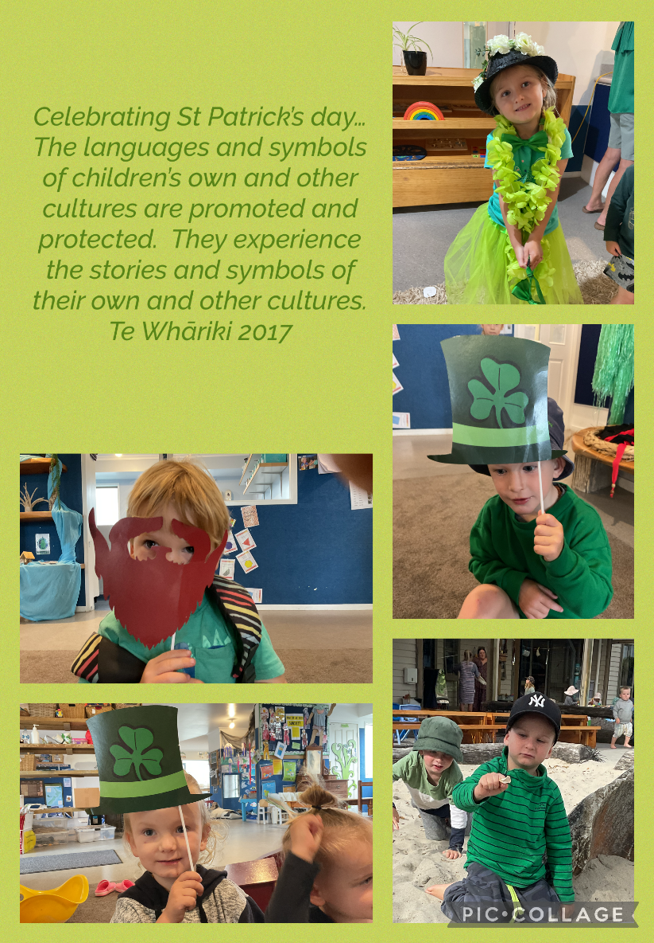
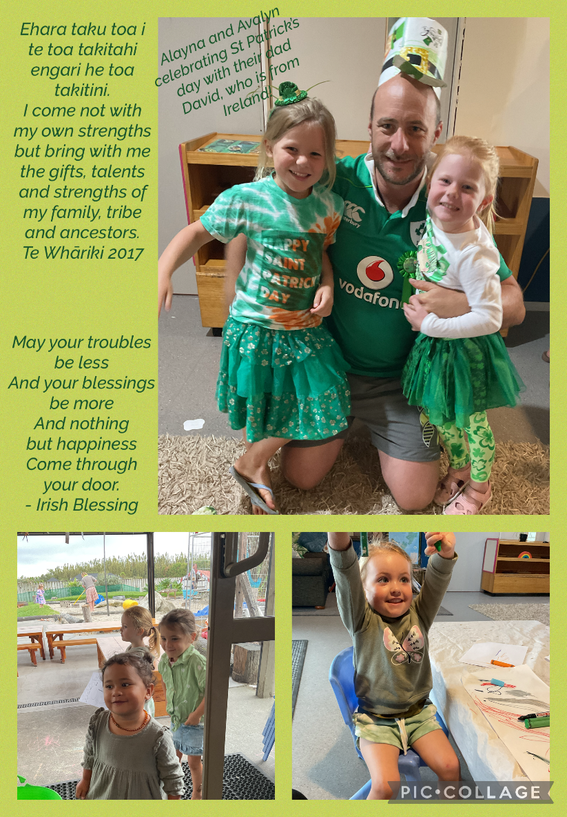
Have a great Easter everyone. Ngā mihi. Noela, Delaine, Debra, Judy, Sonya, Kathy, Amber and Sarah.

