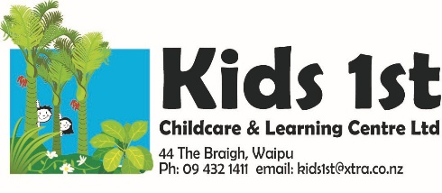

Newsletter
February/March 2021
Nau mai haere mai, welcome whanau. We hope you all had a beautiful Easter with your whanau. Wow this year is scooting away from us! A big thanks to the Halloran and Bell family who hosted us when we evacuated for the Tsunami warning.
Haere mai, a big welcome to Debra Gee, our wonderful new kaiako. You will have met Debra by now, she is working with the tamariki Monday to Friday, with Wednesday off. We look forward to lots of fun and learning with Debra. Her pepeha and introduction will be emailed out to you all to read and is also on the wall.
Haere mai and welcome to the new tamariki and their whanau: Welcome Layla Gilmore and Leah-Rose Vaughan. We look forward to getting to know you and being part of your learning journey. Please feel free to chat with us in regards to your child’s learning and development. We want to know more about your aspirations for your child so we can help you with this.
Haere ra to Coral Camson and her family who are moving, best wishes to you at your new centre Coral. Haere ra to Ryan Hansen and Orion Loomis who off to school soon, happy school days to you both. Our Whakatau to welcome our new whanau was postponed due to the COVID outbreak in Auckland. We will reschedule for next term. Waipu Primary new entrant teachers and children are visiting on Wednesday 7th April from 9a.m. to 11a.m. We invite you to come along and meet the teachers and join us for morning tea.
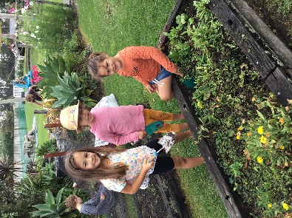
ERO (The Education Review Office) are visiting the centre from Monday 12th to Wednesday 14th April. We look forward to showcasing our centre.
Just a few reminders:
Please label your children’s bags.
Please make sure they have a hat and leave toys at home.
Please scan the QR code and sign in.
Monthly registers are left on the reception desk, these are a Ministry requirement, please check you have signed. Thanks.
Dates to remember: Nature programme: for the eldest 9 children. Please let us know when you can be a parent helper. Dates: April 16th, May 14th, May 28th. We need your help parents or we cannot go. Please see one of the teachers to put your name down.
Coffee Mornings: Come along and meet some other parents, see what your child gets up to and enjoy some morning tea. Held once a month, next date is: Wednesday 7 April, come along anytime that suits. Dates: 7 April, 5 May, 10 June.
Maori Language: To promote Maori language in our community we include some Te Reo Maori in our monthly newsletters for you to have a go with your children. How did the counting song go? Try counting with them up to 10 with this counting song in Te Reo Maori. Tahi is one, rua is two, toru is number three, wha is four, rima is five, 1,2,3,4,5. Ono is six, whitu is seven, waru is number 8, iwa is nine, tekau is ten, 6,7,8,9,10.
Healthy Eating and Active Movement = healthy children Have you considered the screen time your child has? Try adding up the time spent on TV, computers and phones. Te Whāriki (NZ Early Childhood Curriculum) reads: “The child learns through active exploration of the environment. Children learn through play; by doing, asking questions, interacting with others, devising theories about how things work and then trying them out and by making purposeful use of resources. As they engage in exploration, they begin to develop attitudes and expectations that will continue to influence their learning throughout life.” Te Whāriki 2017
Active exploration is the way to go!
Mila, Brooke and Georgia loved being active preparing our garden for autumn planting…
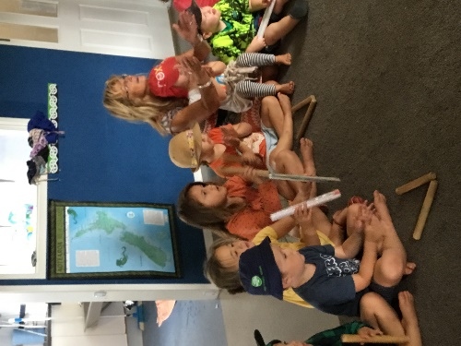
Our Programme: Te Whāriki Principle Empowerment /Whakamana
“Early childhood curriculum empowers the child to learn and grow. This principle means that every child will experience an empowering curriculum that recognises and enhances their mana and supports them to enhance the mana of others. Viewed from a Maori perspective, all children are born with mana inherited from their tipuna. Mana is the power of being and must be upheld and enhanced. To learn and develop to their potential, children must be respected and valued.” Te Whāriki 2017
At Kids 1st Our Kaupapa (Our Ways of Being) embodies this.
Our Kaupapa

(Our Ways of Being)
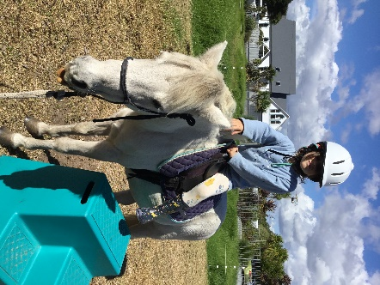

Everything we do…
We do with love in our hearts…
We are kind.

We respect all people, places and things
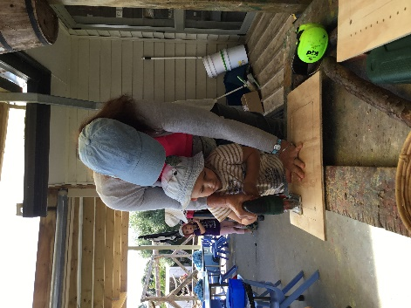
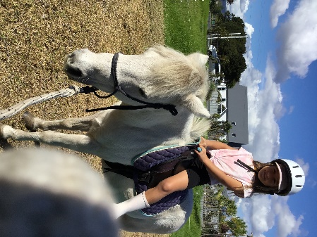
Kids come first at Kids 1st
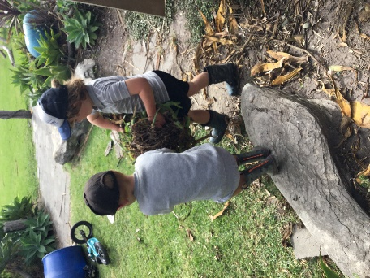
Lots of active exploration with the boys mahi (work). Mac gives Ryan a helping hand. Leo is actively exploring technology with Judy using tools to make a weaving frame.
Happy April! Ka kite ano, Noela, Delaine, Robyn, Kathy, Amber, Sarah, Judy and Debra.
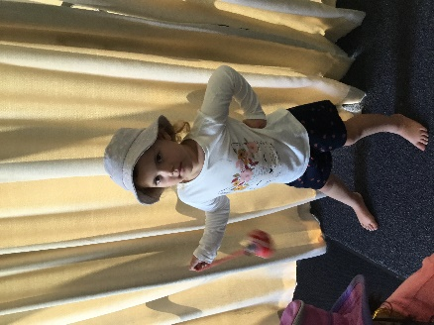
Active exploration of rakau (Maori stick game) with Robyn at Wā Hui.
Indie explores using poi.
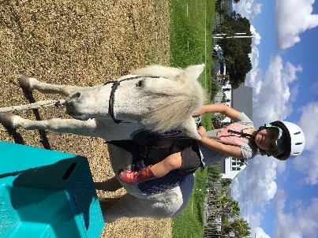
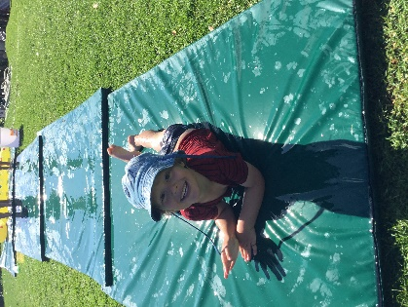
Harry gets active on the water slide!!
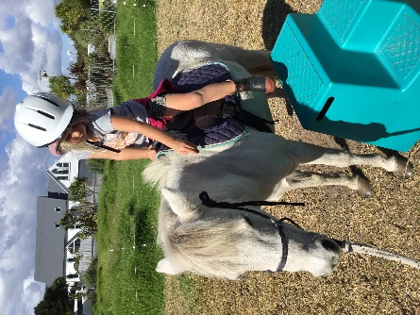
Riding Sparkle is great for our balance and builds our confidence.
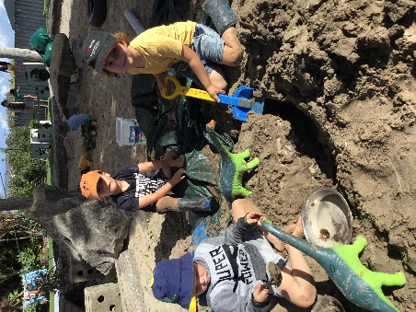
Mason, Leo and Mac exploring science and team work as they construct dams for the dinosaurs.
Kyah and Layla explore music.
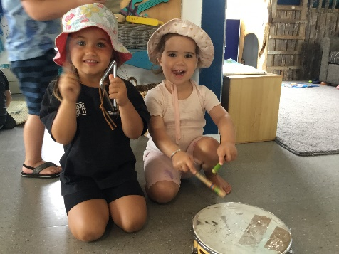
All of this active exploration is empowering, it grows children’s confidence and enhances their mana.

